Project Initiation Form (behavioral)
Fill out as much as you can / feel comfortable doing before sending to PIG. NB: ”Training” means we teach you to do it yourself. ”Assistance” means you want someone else to do it.

Title of project: Does emotional arousal influence metacognition for memory?

Preferred starting date: September 2019

Is there a practical reason why the data cannot be acquired over a short period (e.g. one full week of recording): Yes x No ☐
If yes, specify reason: For this experiment we aim at recording 30 to 35 subjects performing a computer-based behavioral task while measuring their heartrate via ECGs. As there will be individual recordings, we need to book a longer period for acquiring the data (we anticipate about 4 weeks starting in October 1st).

Responsibilities

Primary Investigator
Sebastian Scott Engen (S.S.E) – Bachelor project in Cognitive Science

Primary Supervisor
Micah Allen (M.A.) PI

Contributions
Camile Correa (C.C.) – ECG postdoc at CFIN
Nicolas le Grand (N.L.)- ECG postdoc at CFIN

Responsible for recruitment of subjects:
(S.S.E., C. C.)

Responsible for stimulation (setup, start of recording, and data transfer):
(S.S.E, C.C., N.L.)
Training needed x Assistance needed ☐

Responsible for paradigm programming and program used:
(M.A., N. L. and S.S.E.)
Training needed x Assistance needed ☐
- We have the task already programmed in PsychToolbox but depending on the ECG set-up we may benefit from some initial assistance sending triggers and recording the ECG data.
Responsible for preparation (registration, other):
(S.S.E. and C.C.)
Training needed x Assistance needed ☐
- Basic training to orient us to protocols in the new facilities, and the application of sterile ECG leads to the left and right clavicle.

Responsible for recording: (on-line data quality assurance, data transfer):
(S.S.E., C.C. and N.L.)
Training needed x Assistance needed ☐
- We have prior experience recording and quality checking ECG, but a refresher with the local instruments would be useful particularly for protocol piloting.
Responsible for data analyses:
(M.A., N.Ll and S.S.E.)
Training needed ☐ Assistance needed ☐
- We have good experience calculating instanteous heartrate and other metrics, so shouldn’t help beyond understanding the basic data recording format and reading triggers/etc.
Responsible for idea behind the study:
(M.A. and S.S.E.)

Responsible for writing up of article(s):
(M.A., C.C., N.L. and S.S.E.)

Project description and Hypothesis
Arousal (e.g., emotional and physiological) biases both perception and memory. For example, evidence from our lab and others suggests that pre-stimulus and stimulus-evoked arousal can influence both the decision criterion and confidence during perceptual decisions. Arousal exerts a well-known effect on the acuity and content of free recall, as for example in the “lightbulb” effect in which memory for traumatic, exciting, or otherwise emotionally arousing events is heightened. However, to our knowledge no experiment has investigated whether arousal also influences metacognition for memory (metamemory). This project will adapt a pre-existing task for measuring the sensitivity, bias, and efficiency of metamemory for arousing versus unarousing stimuli. Further, we will test whether stimulus-evoked heart-rate changes mediate the influence of arousal on metacognition.

Main Hypotheses
We expect that high arousal words (e.g., “abuse”, “angry”, “intercourse”) will strengthen memory recall as well as metacognition for memory (metamemory); i.e. an improved correspondence of confidence and accuracy. This will be measured by the d-prime (sensitivity) for recall accuracy, and the m-ratio for metacognitive efficiency, as estimated by a signal theoretic model of metacognition. Stimuli will the top 250 most arousing worse, divided equally by positive and negative valence, all derived from the “Affective Norms for English Words” database. Because a full-blown double translation and revalidation in Danish is not possible, all participants will be selected for having a high level of English fluency, and measures of heartrate and subjective arousal ratings by stimulus condition will provide manipulation checks. Key statistical analysis will be comprised of paired t-tests (aroused vs unaroused word blocks) on d’, confidence, m-ratio. Furthermore, we will fit a hierarchical linear model (mixed effects) describing how participants’ confidence ratings are a function of the words’ arousal levels; we predict that stimulus-evoked changes in heartrate will mediate the influence of accuracy on confidence.

Consistent with the COBIDAS guidelines for reproducibility in neuroimaging and psychological research, all core analyses, hypotheses, and associated power calculations will be pre-registered prior to data collection using the OSF template at our associated project page (https://osf.io/pefnr/). Additionally, all stimuli, task materials, and fully anonymized raw data will be made available on the OSF project website.

Deadlines:
- September 1st: Adapt task for arousal manipulation.
- October 1st - 31st: Data collection
- November – December: data analysis and interpretation
- January – submisson of thesis.
- February – preparation of preprint and journal submission at PLOS ONE or similar (note that our preregistration will help to ensure any null findings are publishable).

Paradigm structure
We will adapt a commonly used measure of meta-memory, see e.g., http://www.jneurosci.org/content/33/5/189 as a key reference. Participants will make a 2AFC judgement for item pairs, to discriminate which have been seen previously in a memorized list. We will adapt this task so that some blocks involve emotionally neutral trials and others high-arousing (positive and negative valence) words. The order of block will be pseudorandomized and counter-balanced across participants to ensure no block to block repetition of arousal condition.

Behavioral tasks. Participants p 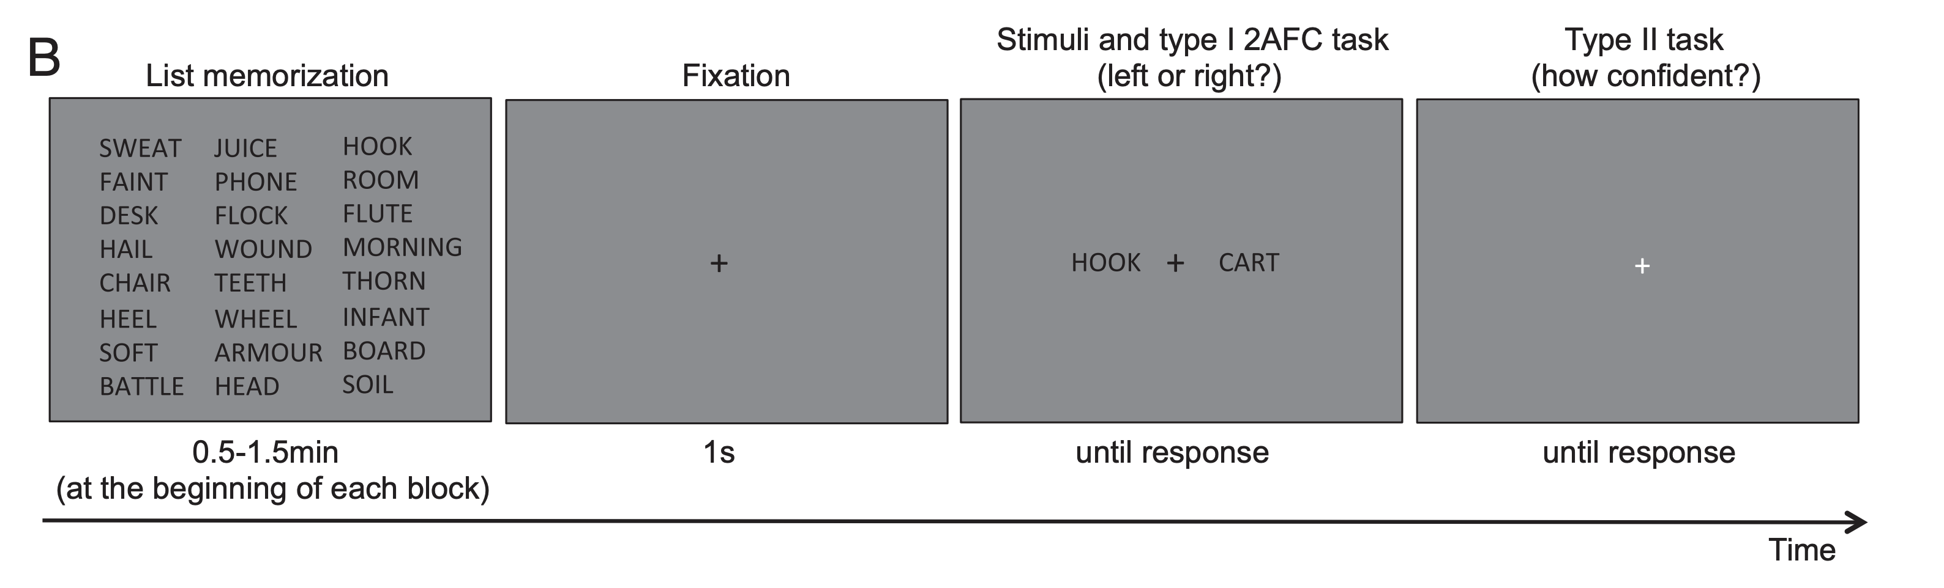-AFC tasks. A, Visual task. Participants viewed two circular stimuli that were presented
y to the left and right of fixation; one stimulus contained only visual noise, and the other
At the beginning of each block of 50 trials, participants study a list of words arranged in 10 rows and 5 columns (an 8 row × 3 column is shown here for ease of display). In each trial, participants viewed two words presented simultaneously to the left and right of fixation; one word had been presented on the study list and the other hand not. Participants performed a 2-AFC judgment, indicating which word (left or right) was on the previously studied list. Subsequently, participants rated how confident they were that their 2-AFC judgment was correct using a 4-point scale (not shown on the screen). Both responses have to be provided within 5 s.

Ethics approval
A template will be provided at the first meeting. The ethics application should be approved for submission by the PIG.

Approved for submission ☐ Approved by local ethics committee ☐ Number:

If ethics approval was sought/received before contacting the PIG, please describe why:

*We want to contact PIG before submitting ethics approval.
We ask clarifications whether it is necessary to submit it to MIDT, and, if not, whether we need an exemption declaration from MIDT.

Resources
Hours of pilot experiments (allow 3 hours per subject):
Approximately 10-15h

Total number of subjects (more than 30 per group is recommended):
Healthy subjects: 35 Patients:0

Hours of pre-screening and interviewing per subject: 0.25

Hours of preparation and recording per subject (less than 1 hour is recommended): 1 hour.

Auxiliary resources
Is clinical assistance needed? Yes ☐ No x

Are injections needed? Yes ☐ No x
If yes, who is responsible, and what is the procedure:

Is special equipment needed? Yes x No ☐
Describe your needs: we would like to record online ECG for stimulus-evoked analyses. Additionally, if feasible we would like to record from the respiration belt so we can pilot some post-hoc measures of respiratory cycle effects.
If yes, can the equipment be bought? Yes ☐ No ☐
If yes, what is the price and who will pay:

Which auxiliary recordings are needed?
ECG x EOG ☐ EMG ☐ GSR ☐ Respiration (optional) x
Eye-tracking ☐ SO2 ☐ CO2 ☐ Temperature ☐
Blood presure (external) ☐ Blood pressure (internal) ☐

Which response boxes are needed?
2x2 buttons (left and right) ☐ 4 buttons (left) ☐ 4 buttons (right) ☐
computer mouse ☐ joystick ☐ keyboard x

What type of sensory stimulation is needed?
Binocular visual x Monocular visual ☐
Auditory (music) ☐ Auditory (voices) ☐
Painful hot stimulation ☐ Painful cold stimulation ☐
Pinprick stimulation ☐ Number of sites:

PIG-space

Hours of recording time allotted to this project (filled out by project initiation group):

